**Swinging Moorings – A Guide to Good Practice **

**How is my boat secured to the river bed?**

A large ground chain runs along the river bed in line with the stream, each ground chain is usually over 100 meters long and is held in place by an anchor each end. Along the ground chain about every 25 meters is a riser chain, this is connected to the ground chain by a shackle. The riser chain passes up through the mooring buoy, through a metal plate and is secured in place with a shackle.

**How should I tie to the mooring buoy?**

Depending on the type of boat you have you may connect to the mooring buoy using either chain or line. The most important thing is to make sure a single swivel is placed between the mooring buoy shackle and your rope/line. The job of the swivel is to prevent your lines becoming twisted and to prevent twist in the lines putting strain on the riser chain. We have seen riser chain damaged because of this, we have had a yacht’s mooring chain break and seen lines so badly twisted that the vessels bow has been damaged. All connections from your boat must be to the top of the swivel.

**Why do I need a back-up Line?**

It is important to use a back-up line in case the main mooring chain or line breaks. This back-up line may be left a little slack and of course it must be secured to the top of the swivel. Ideally the line should be tied to a different on board cleat.

**What if the swivel breaks?**

We have not seen a swivel of any type break. Up until now you have had to supply your own swivel, but over the next 2 years we will be placing a swivel at each mooring buoy free of charge. The swivels we use are rated to 3.3 tons working load and have a 15-ton break load.

**Mooring Chain**

When connecting mooring chain to the swivel use good quality hot-dip galvanised shackles. Be wary of using the type of shackle known as “commercial shackles” as these are poor quality, Zinc plated (shiny) and not load rated.

**Mooring Line**

If using a mooring line, the preferred method for attaching to the top of the swivel is to splice a soft eye in the end of the line and attach with a cow hitch. The drawing below shows attachment to a shackle, but you should attach direct to the top of the swivel. The mooring line should be of the floating type otherwise it will become wrapped around the riser chain, tie a fender or small buoy to the end to warn other river users of rope in the water.

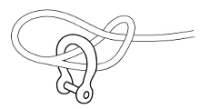

**Protecting Mooring Lines**

Ensure that your mooring lines are more than adequate. It is a good idea to use plastic pipe over mooring lines at points of chafe such as fairleads or bow rollers, held in place by short cords passed through the lay of the line.

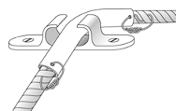 

Rubber shock absorbers (sometimes called mooring compensators) fitted to lines will help prevent snubbing and reduce wear and tear. You must fit them before splicing eyes in the ends of the line!

**Where do failures occur?**

There are many ways for a mooring to fail and a boat to drift free, these are some of the failures we have seen over the past 2 years. Mooring lines chaffing through and breaking. Cable ties holding shackle pins in place get caught in the mooring gear and break or degrade through UV light, the pin then works loose and falls out. Chain or line jumping out of a bow roller and wearing through the deck. Lines twisting and breaking. Chain twisting and breaking.

**What to do?**

* All connections must be made through a swivel.
* Use good quality hot-dip galvanised shackles.
* All shackles must have pins that can be held in place with appropriate seizing wire.
* For seizing wire use Monel or Stainless Steel 316.
* A back-up line must be used and connected to the top of the swivel.
* Lines and chain must be under tension so that the swivel can rotate freely.
* Deck bow rollers & cleats must be strongly built to withstand the loads, especially during a storm.
* If it looks neat and tidy then it is probably strong and it is certainly easy to inspect regularly.

**Please don’t!**

* Do not use 2 swivels, it does not work and the lines will twist.
* Do not pull the buoy out of water, as the waves will cause the buoy to ride up and down the riser chain, wearing through the buoy.
* Do not use cable ties.

**How can Queenborough Harbour help you?**

* We will provide and fit a heavy-duty swivel free of charge, just ask.
* We sell stainless steel 316 seizing wire for £3 per reel.
* We will help you secure your mooring lines free of charge.
* If there are old items of mooring gear on your buoy, let us know and we will remove them.

If you have any comments regarding this Guide to Good Mooring Practice, please let us know.

The next page shows photos of good, bad and ugly mooring practice!

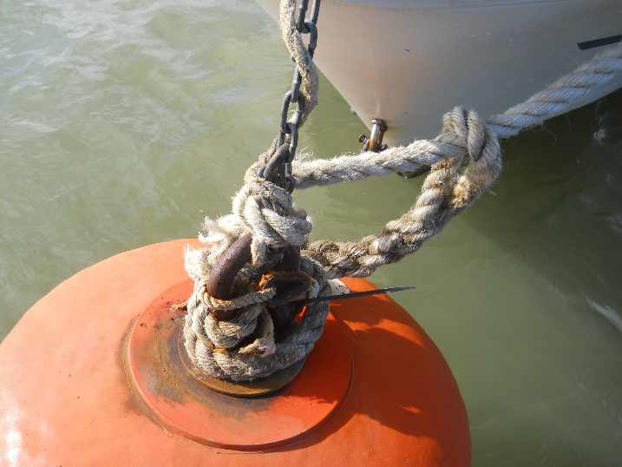 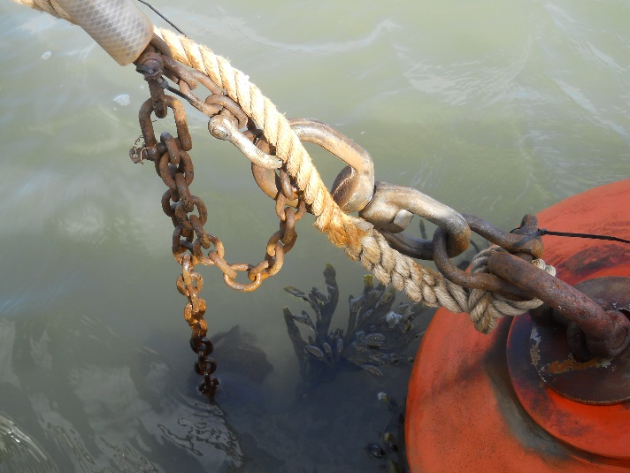

 No Swivel  Back-up line not to swivel

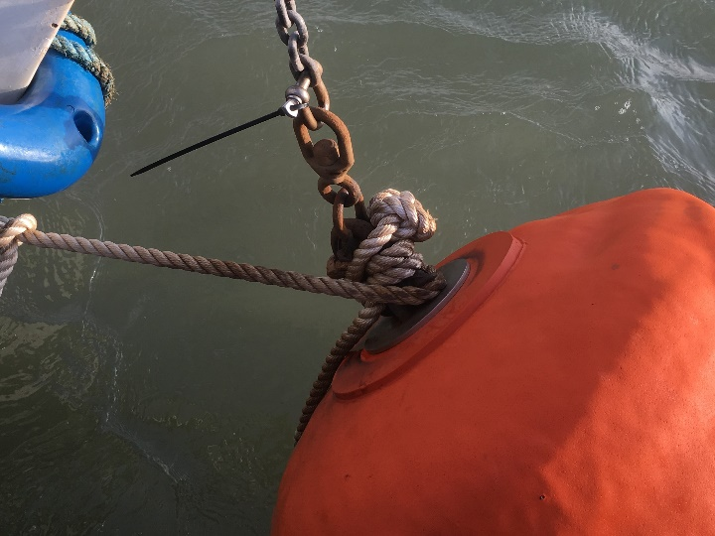 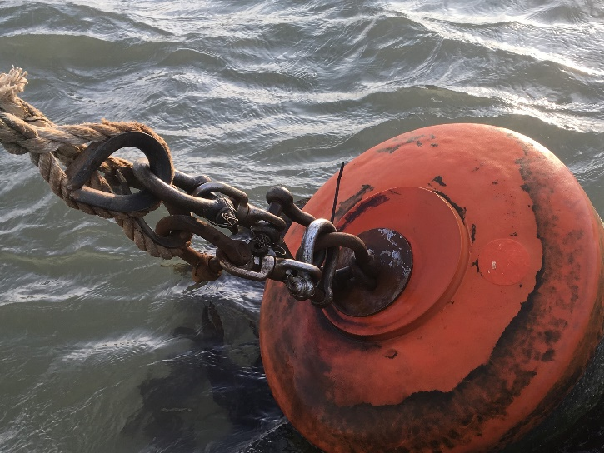

 Back-up line not to swivel  Two swivels

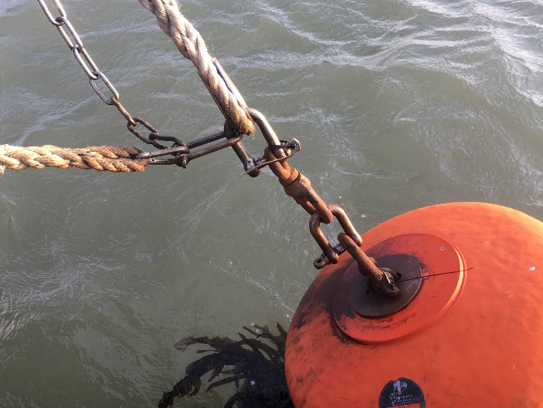 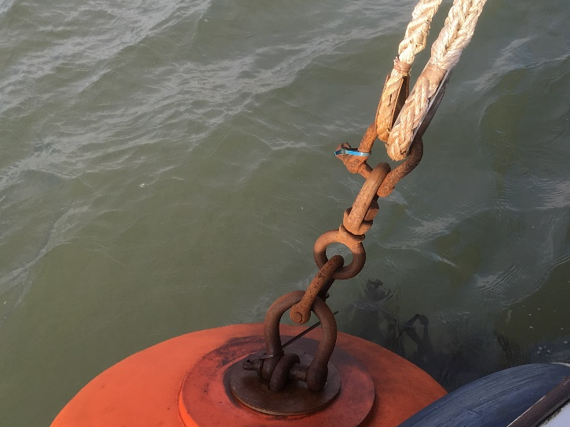

 Neat and secure  Neat and secure